AIM
To write a Python program using Pandas and NumPy to identify and handle missing values in a DataFrame using null value detection, row deletion, and different methods of filling missing values.

ALGORITHM
- Start the program.
- Import the Pandas and NumPy libraries.
- Create a dictionary containing Name, Age, and City columns with some missing values represented by np.nan.
- Convert the dictionary into a Pandas DataFrame using pd.DataFrame(data).
- Display the original DataFrame.
- Identify and count missing values in each column using df.isnull().sum().
- Remove rows containing missing values using df.dropna() and display the cleaned DataFrame.
- Replace all missing values with 0 using df.fillna(0) and display the result.
- Create a copy of the original DataFrame and replace missing Age values with the mean age using df_mean_filled["Age"].fillna(df_mean_filled["Age"].mean()).
- Create another copy of the original DataFrame and replace missing City values with "Unknown".
- Display the results of each missing-value handling method.
- Stop the program.
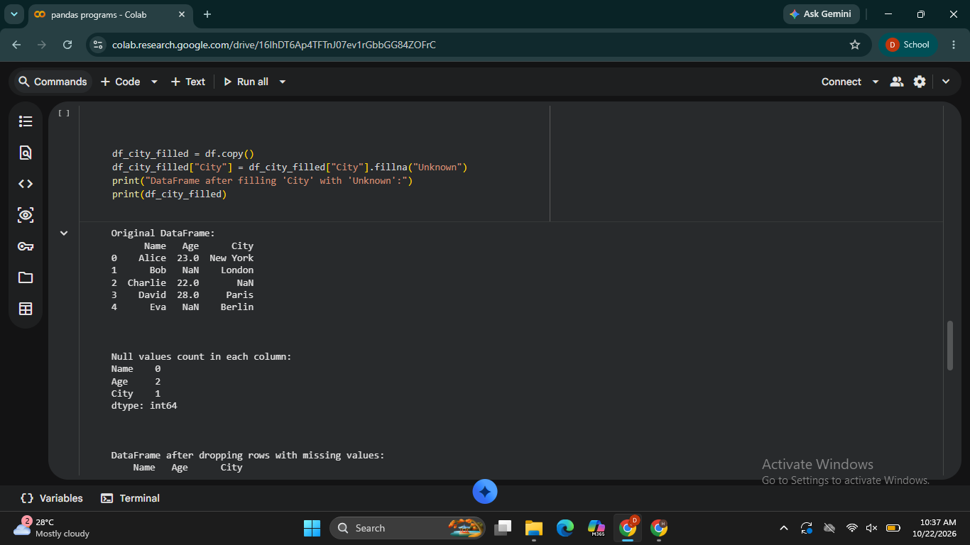
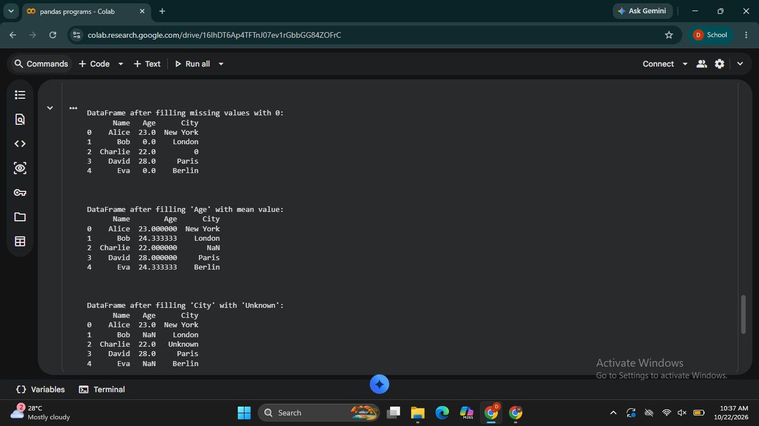

RESULT
Thus, the Python program using Pandas and NumPy was executed successfully to detect and count missing values, remove rows containing missing data, replace missing values with zero, fill missing ages with the mean, and replace missing city names with "Unknown".

